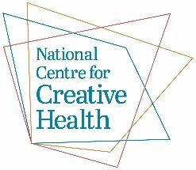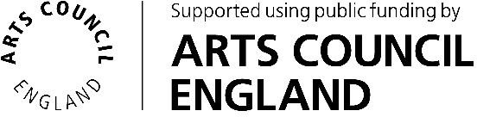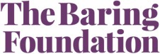

Creative Health Leads in Systems – Application Form
Please complete as much of this form as possible. If you have any questions about any section, please contact us for support – email jayne@ncch.org.uk
The text boxes will expand as you type.
Section 1: Contact Details
Person completing the form
- Name:
- Job title:
- Organisation:
- Email:
- Telephone number:
Person with whom we should liaise on this application (if different)
- Name:
- Job title:
- Organisation:
- Email:
- Telephone number:

Section 2: Your proposal
Please outline how you think the Creative Health Lead (CHL) role will work within your organisation and across the wider system.
(Word count guideline: 300–500 words)
You might include:
- Priority areas of focus
- Links with existing strategies or plans (e.g. neighbourhood health development, care pathways, integrated care priorities)
- How the role will connect across teams, partners, and communities

Section 3: Employing Organisation
- Name of employing organisation:

- Department or team in which the CHL will be located:

- Line manager (name and job title):

Section 4: Employment Contract and Support
- Length of contract:
- Hours of work:
- Salary:
If the CHL is not employed within the NHS, please confirm that the postholder will have by clicking on the check box:
- An NHS honorary contract ☐
- An NHS email address ☐
- Access to a named individual in an NHS organisation for support ☐
Is there an existing structure (e.g. Partnership Board, Network, Group, or Committee) that will support or oversee the Creative Health Lead role? ☐
Please describe and attach any terms of reference if available.

Section 5: Funding
Please indicate the total amount of match funding available : £
If this funding is only available in certain financial years please indicate the amounts and years below:
- 2025–26:
- 2026–27:
- 2027–28:
- 2028–29:
(Note: We are flexible about how funding is allocated/matched across financial years – this is for planning purposes.)
Which organisation(s) and budget(s) is the match funding coming from?

(Note: Match funding cannot come from arts or culture budgets)
Section 6: Priority areas and existing work
Health inequalities
We are particularly interested in roles that address health inequalities and/or work in more deprived areas. Please outline how this relates to your proposal, if at all.

Social care
We are particularly interested in roles that can demonstrate links with social care priorities and services. Please outline how this relates to your proposal, if at all.

Existing creative health work
We want to support roles in both areas where work is not very well-developed as well as in those where there is existing work but scope for further development. Please outline any existing creative health work of which you are aware that is relevant to your proposal.

Section 7: Partnership
Please list all partners involved in this proposal. If your application is successful, a formal Partnership Agreement will be required, signed by representatives of all listed partners.
Partner 1:
- Name of partner organisation:
- Name of lead contact:
- Email address:
- Role in the partnership (if specified):

Partner 2:
- Name of partner organisation:
- Name of lead contact:
- Email address:
- Role in the partnership (if specified):

Partner 3:
- Name of partner organisation:
- Name of lead contact:
- Email address:
- Role in the partnership (if specified):

Please repeat this information for any further partners who are involved.

Section 8: Commitment to Development Programme
If your application is successful, the postholder will be expected to participate in the national learning and development programme coordinated by NCCH.
This includes:
- An induction to the programme which will be a commitment of up to 6 hours in the first month
- Peer learning sessions every six weeks (up to 3 hours each)
- Optional drop-in development sessions with the Programme Manager
In addition, there will be a system development programme, including workshops on strategy and the development and testing of tools and frameworks to support creative health development in systems. If your application is successful we would expect relevant people from across your system to engage in this programme as much as possible.
I have read and understood the expected commitment to the Development Programme ☐

Section 9: Supporting information, documents and links
If there is any further information that you would like to add to this application, please do so here
If you have attached any documents, please list them here:
Please feel free to add up to 3 weblinks that will help us understand and assess your application

Applicant name:
Signature (digital signature is accepted):
Date:

Please send this form to jayne@ncch.org.uk
Application deadlines:
Friday 18th September 2026, 2359 hours
Please note: Shortlisted applicants will be invited to attend an online interview on Wednesday 14th October 2026.

